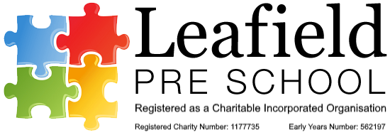

**14 First aid**

**Policy statement**

In our setting, staff are able to take action to apply first aid treatment in the event of an accident involving a child or adult. All staff have first aid training in line with the EYFS. The first aid qualification includes first aid training for infants and young children. We aim to ensure that first aid training is local authority approved and is relevant to staff caring for young children.

**Procedures**

*The first aid kit*

Our first aid kit is accessible at all times, complies with the Health and Safety (First Aid) Regulations 1981. The content of the first aid kit is replaced when used and checked termly by the settings H&S representative.

* The first aid box is easily accessible to adults and is kept out of the reach of children.
* All medication (prescribed or non-prescribed) will only be given to a child with written permission from the child’s parent/carer. A written record is kept of the date and time given and this information is relayed to the parent/carer at the end of the session.
* Prescribed medication will only be given if it has been prescribed for a child by a Doctor, Dentist, Nurse or Pharmacist.
* At the time of each child’s admission to the setting, parents' written permission for obtaining emergency medical advice or treatment is sought. Parents sign and date their written approval.
* Parents sign a consent section in the registration form allowing staff to take their child to the nearest Accident and Emergency unit to be examined, treated, or admitted as necessary on the understanding that parents have been informed and are on their way to the hospital.

------------------------------------------------------------------------------------------------------------------------------------------------------------------------------------------------