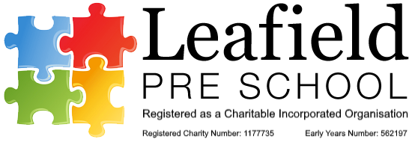

**Transfer of records to school/settings**

**Policy statement**

We recognise that children sometimes move to another early years setting before they go on to school, although many will leave our setting to enter a reception class.

We prepare children for these transitions and involve parents and the receiving setting or school in this process. We prepare records about a child’s development and learning in the Early Years Foundation Stage in our setting; in order to enable smooth transitions, we share appropriate information with the receiving setting or school at transfer.

Confidential records are shared where there have been child protection concerns according to the process required by our Local Safeguarding Children Board.

The procedure guides this process and determines what information we can and cannot share with a receiving school or setting. Prior to transferring information, we will establish the lawful basis for doing so (see our Privacy Notice).

**Procedures**

*Transfer of development records for a child moving to another early years setting or school*

* The key person will prepare a summary of achievements in the seven areas of learning and development.
* The record refers to:
  + any additional language spoken by the child and his or her progress in both languages;
  + any additional needs that have been identified or addressed by our setting;
  + any special needs or disability, whether a CAF was raised in respect of special needs or disability, whether there is an Education, Health and Care Plan, and the name of the lead professional.
* The record contains a summary by the key person and a summary of the parent’s view of the child.
* The document may be accompanied by other evidence, such as photos or drawings that the child has made.
* When a child transfers to a school, most local authorities provide an assessment summary format or a transition record, which we will follow as applicable.
* If there have been any welfare or protection concerns this will be discussed by the DSL to the new teacher or school DSL and ecords transferred via Cpoms

*Transfer of confidential information*

* The receiving school or setting will need to have a record of any safeguarding or child protection concerns that were raised in our setting and what was done about them. This will be transferred to them via Cpoms.
* Where a TAF has been raised in respect of any welfare concerns, we will pass the name and contact details of the lead professional on to the receiving setting or school.
* Where there has been an investigation regarding a child protection concern, we will pass the name and contact details of the child’s social worker on to the receiving setting or school – regardless of the outcome of the investigation.
* All safeguarding information is passed onto the new setting using CPOMs.
* We do not pass any other documentation from the child's personal file to the receiving setting or school.

----------------------------------------------------------------------------------------------------------------------